http://www.slideshare.net/bcpsqc/polypharmacy-jan-16-17-no-notes-30318249
Shared Care (Mhezbin Chris and Keith)
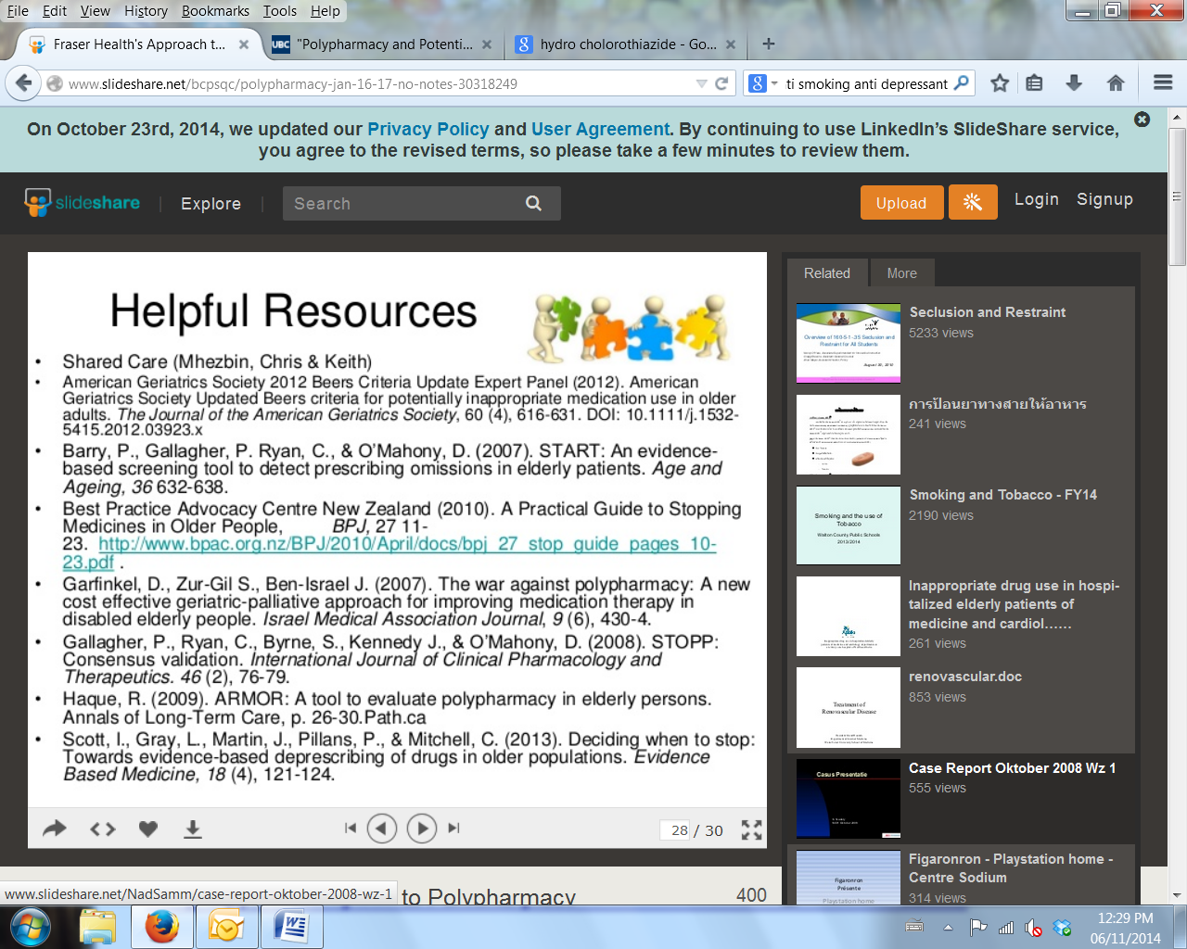
https://www.youtube.com/watch?v=PXoLsW0w1FE&rel=0

- Re-evaluate the goals of therapy
  - Decision Making About Change of Medication for Comorbid Disease at the End of Life: An Integrative Review

- Symptomatic
- Preventive
- Apply absolute risk differences
- Consider simple pharmacology and physiology
- Avoid unnecessary drug costs
- Reassess the ongoing value of individual and combination drugs
- Use common sense and the Golden Rule
- Aim to stop at least 1 drug and monitor

